Installation Guide & User Manual

Single sign on (sso) Application

Thayalan Benjaman

2018

Table of Contents

System Requirements 2

Hardware 2

Software 2

Database 2

Run SSO Application 2

Login Credentials 3

User Manual 4

Login to SingleSignOn Application from WebApplication 4

WebApplication Home Page 5

# System Requirements

To ensure the best performance using SSO Applications, please note the following requirements for hardware and software:

## Hardware

* 2GHz processor (2.5GHz, recommended)
* 2 GB RAM (4 GB, recommended)
* 50 MB hard disk storage
* 1280x720 screen resolution

## Software

* Windows 7 or higher
* Chrome Browser 60.0 or later
* Visual Studio 2015 or 2017

## Database

* Microsoft SQL Server 2017 with Management Studio 17

# Run SSO Application

Before compile and run SSO application, make sure your computer meets the minimum requirements necessary for using SSO application. (See “System Requirements” on above section.)

**To compile and run SSO Application**

1. Open Visual Studio as Administrator. (To make sure all the functions work smoothly.)
2. Set WebApplication project as startup project by right-click on the project and set as startup project. **Note: If WebApplication project is not set as startup project.**
3. Rebuild the WebApplication project by right-click on the project and click rebuild. (WebApplication is second web application which just have home page)
4. Before run the project, need to attach the SQL database in the Microsoft SQL Server and follow the instructions below:  
   1. Open the SQL Server Management Studio 17  
   2. Connect to Instance Name that available and right-click on the databases then click attach.  
   3. Click on Add button and choose the SSO mdf file will be located at project file in App_Data folder.  
   4. Click on OK button to allow the system to attach the SQL database into the server.
5. Once done attach the database file, on SingleSignOn project click on Web.config file and check the connection string for the SQL Server that make sure it is correct.
6. Click on debug using Chrome Browser and the WebApplication will be redirect to login page that located in SingleSignOn application. (For the login credentials that already created in database please refer on page 4.)

# Login Credentials

|  |  |  |
| --- | --- | --- |
| No. | Username | Password |
| 1 | thaya | thaya12345 |
| 2 | testing | test12345 |

# User Manual

## Login to SingleSignOn Application from WebApplication

This page is redirect from WebApplication and this page are in SingleSignOn Application. If the user wants to view the home page from WebApplication, the user need to login from SingleSignOn Application before exploring into the WebApplication.

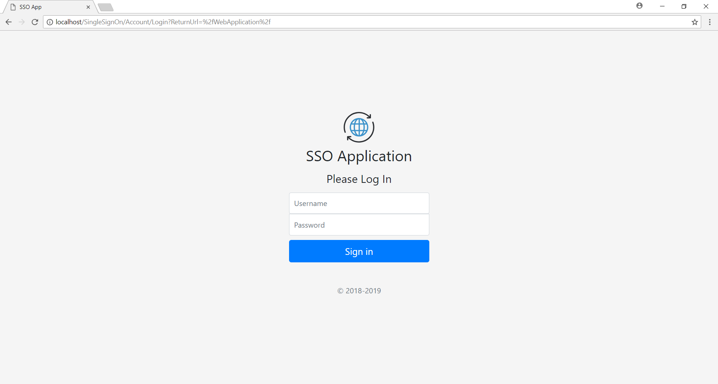

Figure 1 Login page from SingleSignOn Application

1. Please enter the username and password that provided on page 4.
2. Click on Sign In button to login to WebApplication and the page will redirect to WebApplication Home page (Figure 2).

## WebApplication Home Page

This home page will appear after success login into SingleSignOn Application Login page. This home page will have the username that the user has login at the body content.

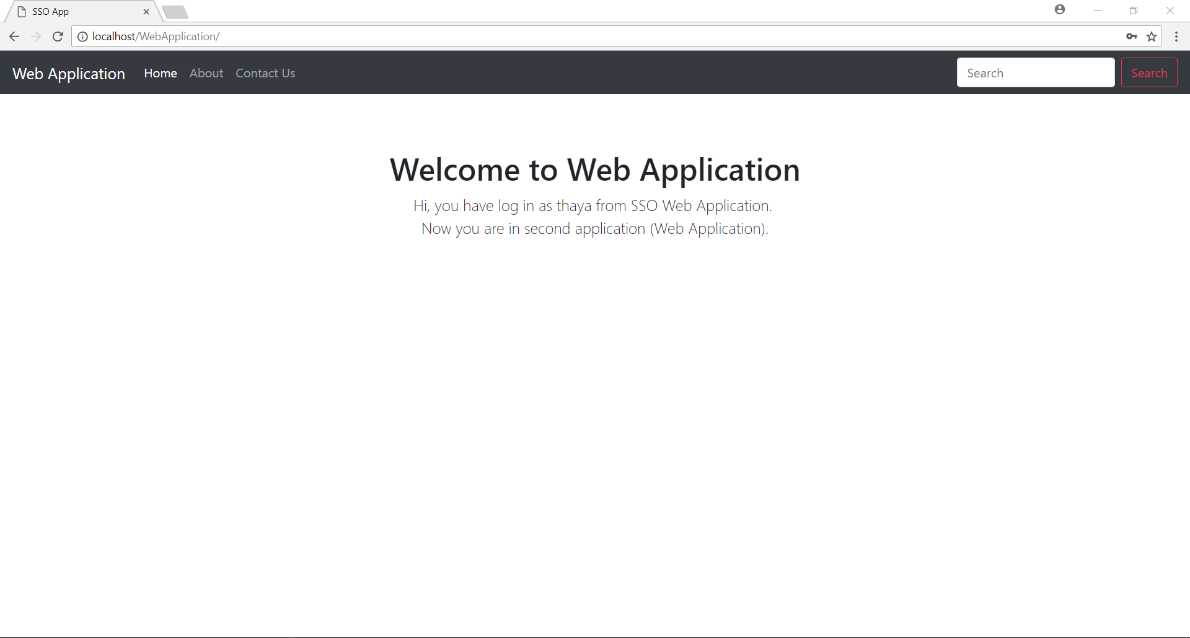

Figure 2 Home Page of Web Application